AI
Assignment-1
Task Description#1
● Install and configure GitHub Copilot in VS Code. Take screenshots of each step.
open vs code and in the extension search for git hub copilot and install
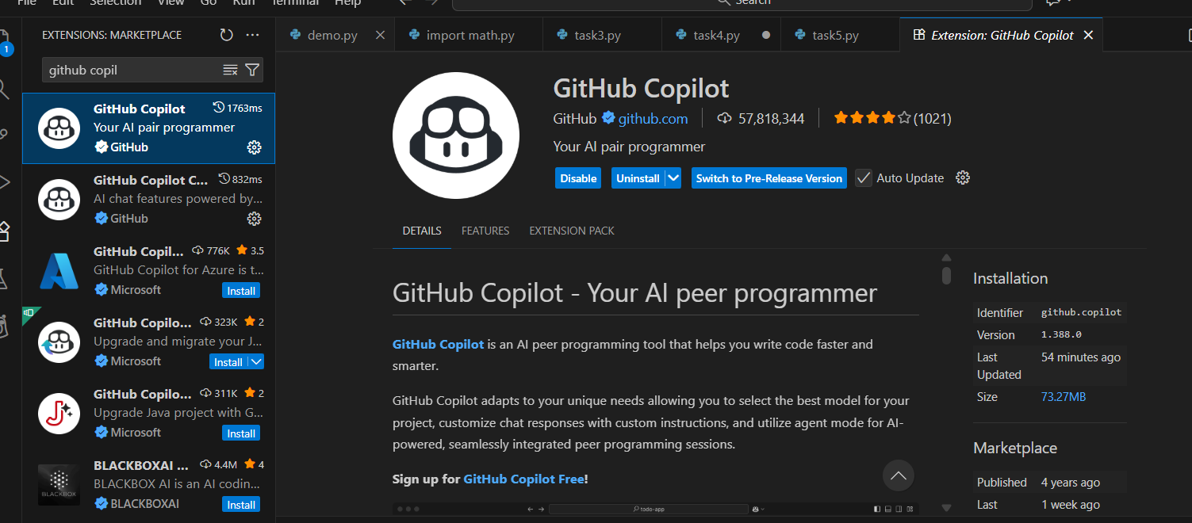
Sign in to GitHub
- VS Code will ask to Sign in to GitHub
- Click Allow
- Login to your GitHub account in browser
Enable GitHub Copilot
After login, Copilot activates automatically.
To confirm:
- Go to Settings → Extensions → GitHub Copilot
- Ensure toggle is ON
- Create a new file: test.py
- Type comment:
- #write a python function to print hello world
Copilot should auto-suggest code

Task2 :-
Use Copilot to generate a is_prime() Python function
Prompt:- write a user input python code to generate is_prime()
Solution:-
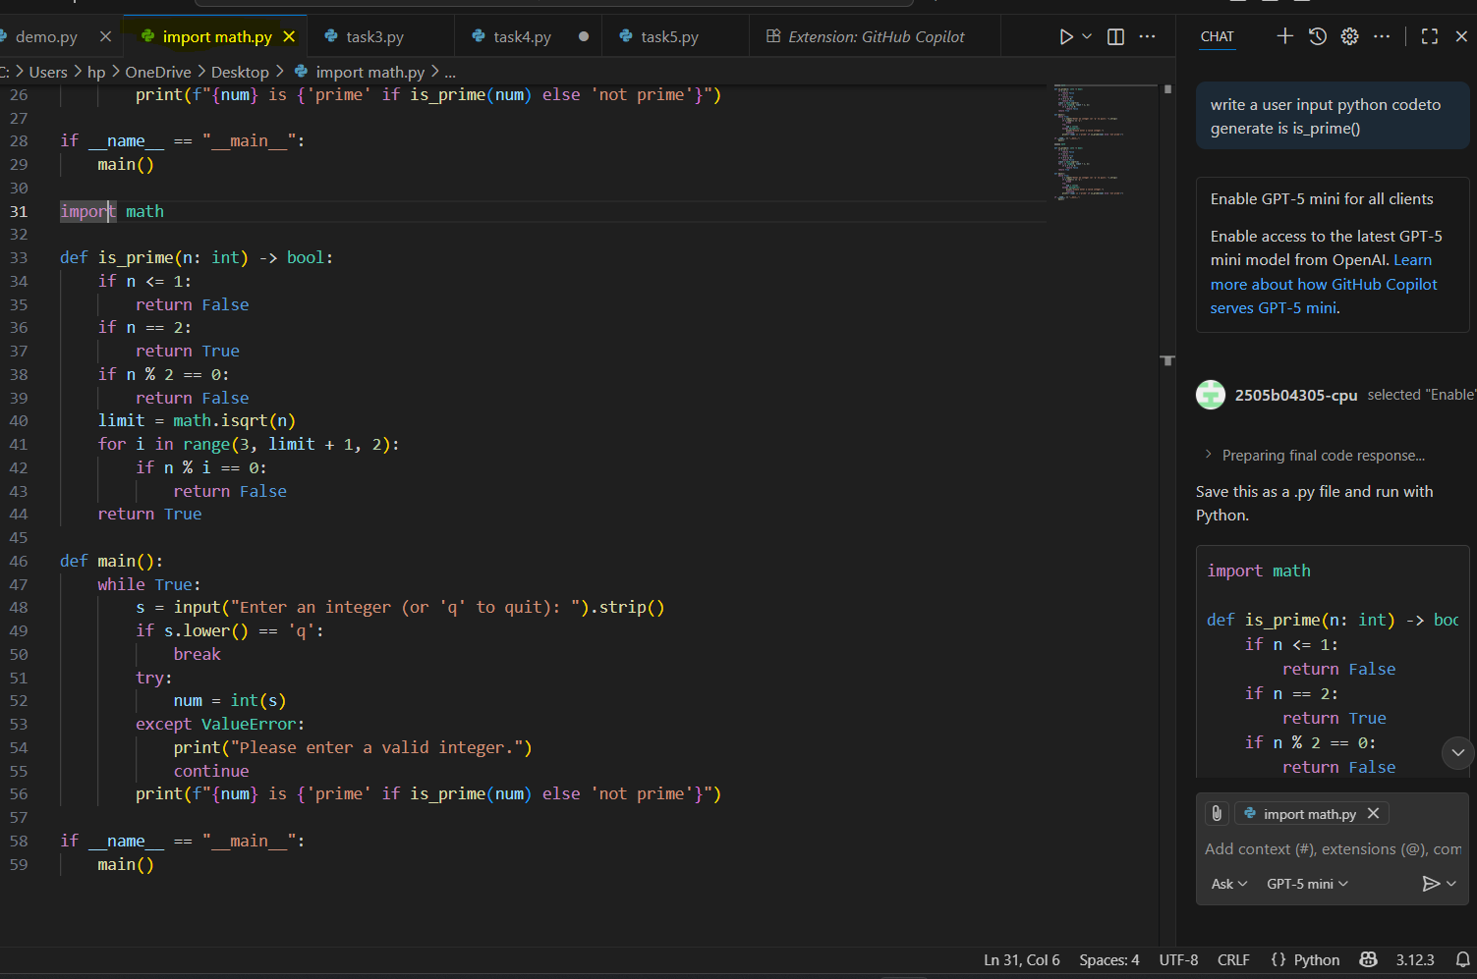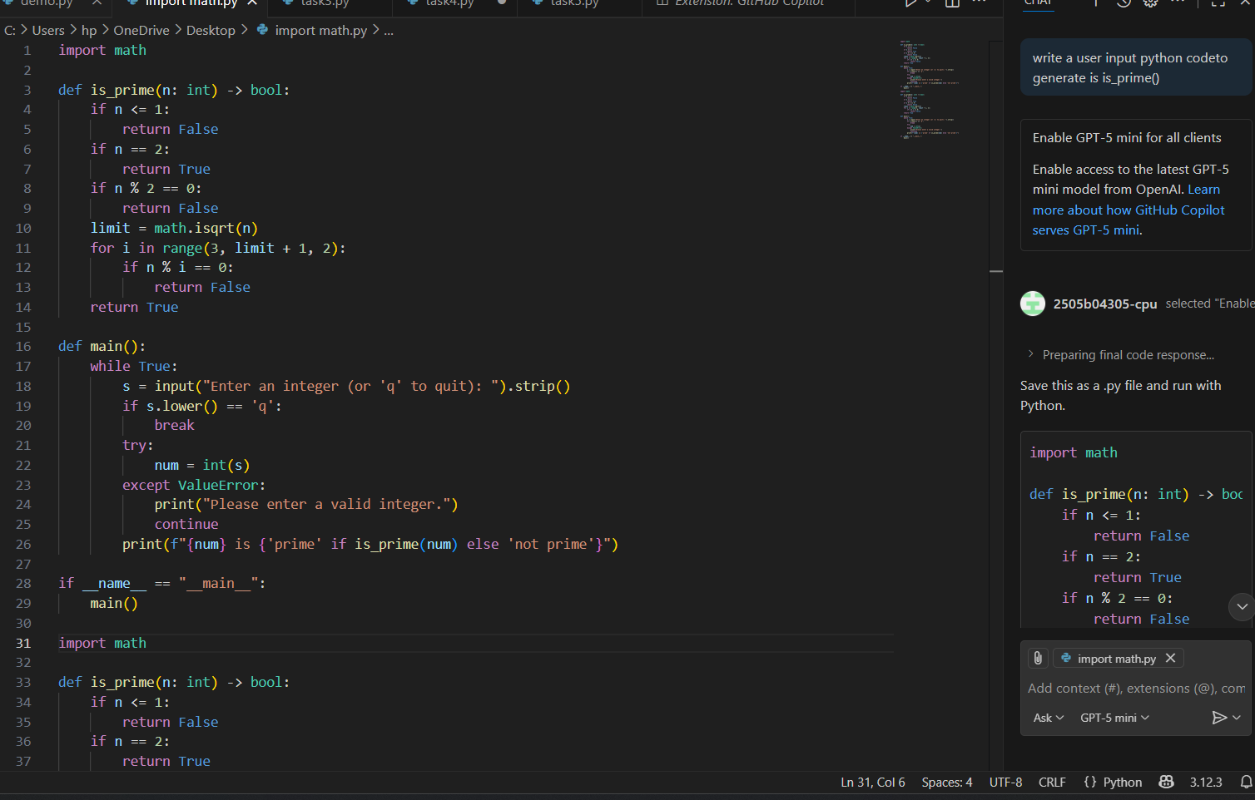

Task 3 :-
Write a comment like # Function to reverse a string and use Copilot to generate the
function
Prompt:- write a python code to reverse a string
Solution:-
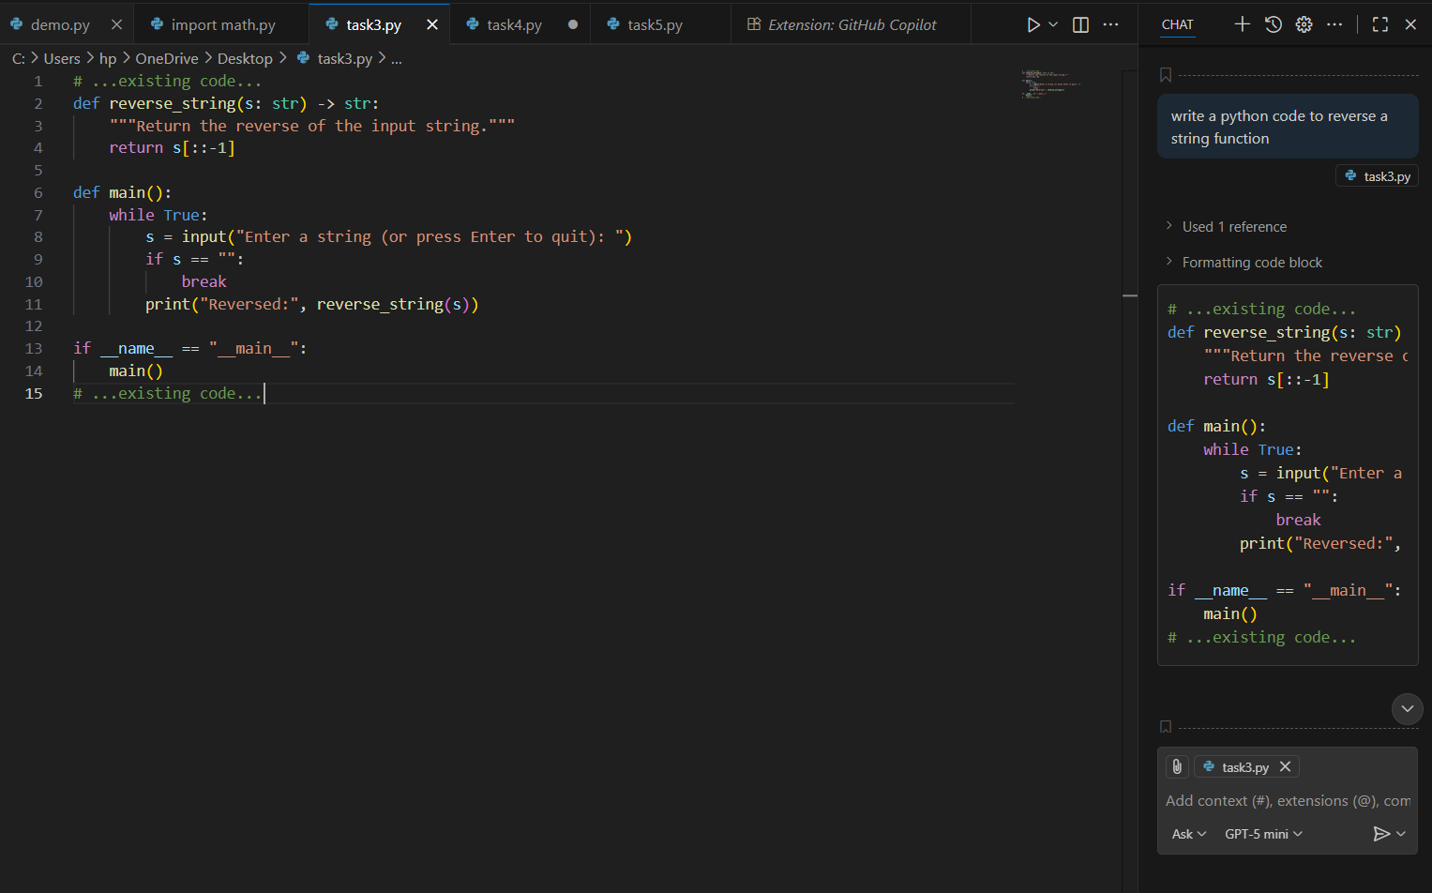

Task 4 :-
Generate both recursive and iterative versions of a factorial function using comments.
Prompt:-
Generate both recursive and iterative versions of a factorial function in Python with clean comments explaining each step.
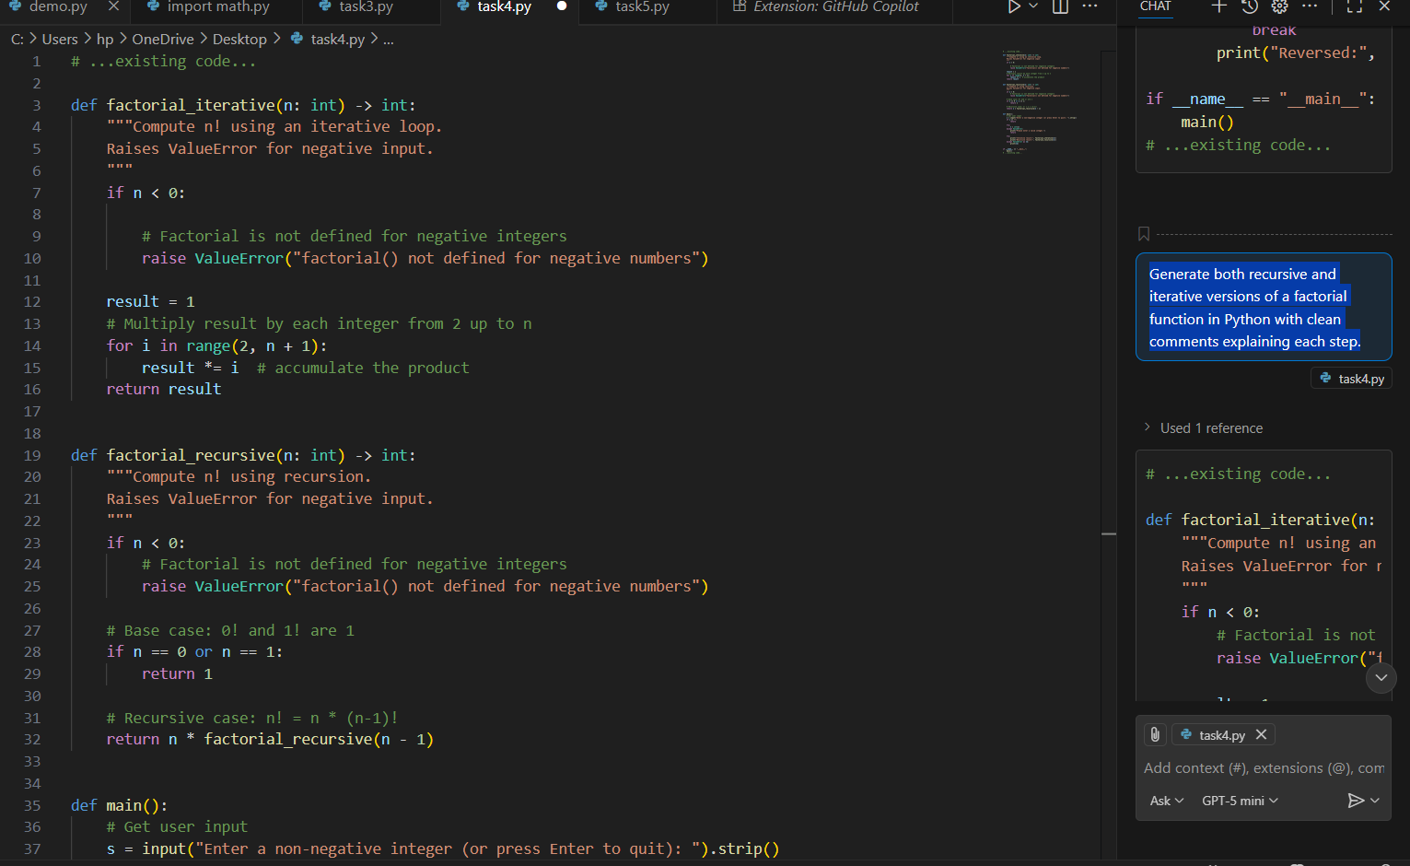

Task 5:-
● Use Copilot to find the largest number in a list. Assess code quality and efficiency
Prompt:- Write a Python function to find the largest number in a list without using the built-in max() function.
Then print the result for the list [1, 3, 5, 2, 4].
After generating the function, describe the code quality, time complexity, and any edge cases
